Minding The Gap Case Study: Aaron

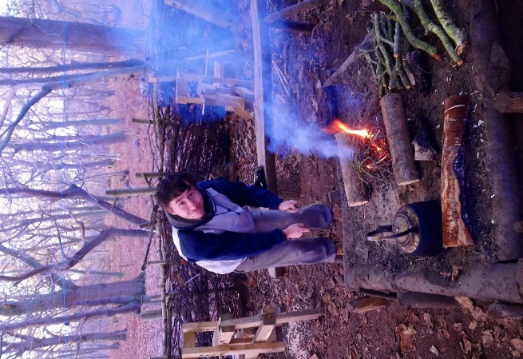 | Before Aaron engaged with Lapwing and this project, he described himself as “doing nothing”. He spent most of his days at home playing video games, disconnected from the outside world. Aaron has cystic fibrosis and, as a result, he faces ongoing challenges, not least the reduced life-expectancy this condition brings.  Lapwing worked with Aaron to build his confidence and identify a way forward to motivate him. As part of the project offer, we enrolled him on the Young Futures course with Green Light Trust (a project delivery partner) and as soon as he started attending the sessions, it was clear that he was in the right place. From day one he has been enthusiastic about rising to the challenge. Whether it is bush craft skills, path maintenance, habitat creation or woodland management, Aaron has been keen to get involved and has developed a proactive attitude.  In between sessions Aaron has been buying his own tools and equipment to further his interests in the outdoors outside of his time with Green Light Trust. This has clearly sparked an interest which has given him a new purpose, a more active lifestyle and increased his self-confidence.  Aaron has a phobia of spiders but through encouragement and specific sessions focused on wildlife interaction, Aaron has managed to push himself to actually handle a spider. As well as working on overcoming his fears, Aaron is now taking on other challenges beyond the course. He is applying for part time jobs and retaking his GCSEs with a view to applying to go to college to do a horticulture or arboriculture course.  The project has seen Aaron develop into a self-motivated participant who now comes up with his own personal development ideas and then works to make them become a reality. His infectious energy also rubbed off on the rest of the group and helped to motivate others to push themselves in a positive way.
